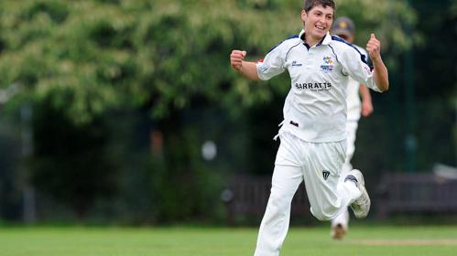
LONDON MACCABI VALE

CRICKET CLUB

COLTS SECTION

Ages 9-15

TRAINING SESSIONS HAVE STARTED!
Yavneh College, Hillside Avenue, Borehamwood, WD6 1HL

U13s, U15s
7:30pm-8:30pm
U9s, U11s
6:30pm-7:30pm

ANNUAL MEMBERSHIP 2018
£180 for the full season
£120 for the summer only

Email: lmvcolts@gmail.com
Call: Anthony Wise, 07951953313

London Maccabi Vale Cricket Club operate under the ECB’s “Safe Hands” policy, with staff trained in the welfare of young people

